**Learning Live - Newsletter**

**Top 5 Countries**

Turkey

Uganda

Pakistan

India

USA

**Top 5 Learners**

Pranay Das

Miriam De Silva

Robb Mumford

Kumar Randema

Lalita Peiris

**159**

Active Users

**201**

Completions

**14**

Countries

**Fast Facts**

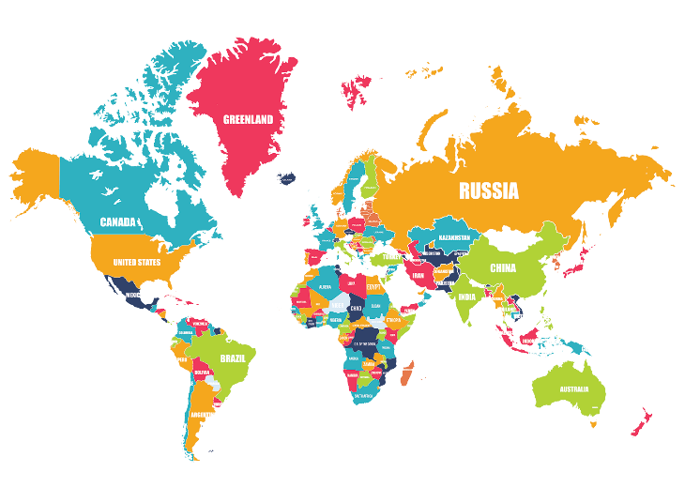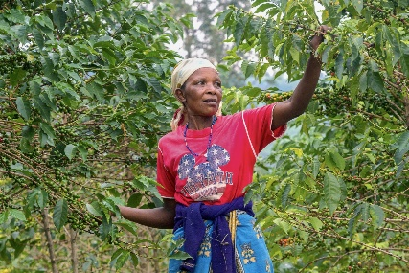

**COURSE AND EVENT Announcements**

**Online:**

PMD PRO Flex – December 05, 2016: Registration Open

**Classroom:**

Child Protection Training – November 29, 2016 – Uganda office

**New learning:**

Financial management Learning Path – Online program, enrol today!

Introduction to Sexual Exploitation and Abuse

Project Management - Module 4: Project Planning

Project Management - Module 4: Project Planning

People Management - Discrimination and Harassment Prevention Training

Advanced Excel - PivotTables and PivotCharts in Excel 2010

**TOP COURSES**

nostrum detraxit pericula, erat concludaturque mel ei. Rebum tractatos inciderint vis ea, pri ea congue referrentur delicatissimi. Vel ut primis ornatus. Ne mei vidit quaestio. Read More here….

**[TITLE]**

[Focus story ideally on field staff learning]

Lorem ipsum dolor sit amet, mea dictas regione consequuntur ut. Ne esse disputationi has. Eu his

**CEO BOOK OF THE MONTH**

The Social Leadership handbook - *by Julian Stodd*

**TED TALK OF THE MONTH**

[Teach girls bravery, not perfection](https://www.ted.com/talks/reshma_saujani_teach_girls_bravery_not_perfection) – *by Reshma Saujani*

**BLOG OF THE MONTH**

[What life is like when a girl marries at 11](http://www.huffingtonpost.com/entry/child-marriage-memory-banda_us_57ed4542e4b024a52d2d7441?section=us_impact) - *by Eleanor Goldberg*

**CONTACT US**

If you have any questions about learning Email: support@lingos.org